Topic 13: Oscillations

1.3 Specification notice:
In order to develop their practical skills, students should be encouraged to carry out a range of practical experiments related to this topic. Possible experiments include measuring gravitational field strength using a simple pendulum and measuring a spring constant from simple harmonic motion.

Mathematical skills that could be developed in this topic include sketching relationships that are modelled by y = sin x, y = cos x.

13.Q Exam questions

13.181 understand that the condition for simple harmonic motion is F = − kx, and hence understand how to identify situations in which simple harmonic motion will occur
what are the conditions for an object to undergo SHM? | - An object’s acceleration or resultant force is proportional to displacement from the equilibrium position  - Its acceleration or resultant force must be directed towards the equilibrium position  So…  A= -w²x from a prop -x  Thus, the same is expected of the restoring forces
Why is SHM only a good approximation for a pendulum at small angles? | As the displacement (straight line path) is close enough to the curved path (until about 10 degrees)

13.182 be able to use the equations $a = -Aω^{2}x, x= Acos ωt, v = -Aωsin ωt, a = -Aω^{2}cos ωt,$

$and T=\frac{1}{f}=\frac{2π}{ω} and ω=2πf$ as applied to a simple harmonic oscillator
What are the equations for SHM for displacement, velocity and acceleration and how is acceleration related to displacement? | - x = Acos($ω$t)⍵  - v = -A$ω$sin($ω$t)  - a = -A$ω$²cos($ω$t)  - a = -$ω$²x  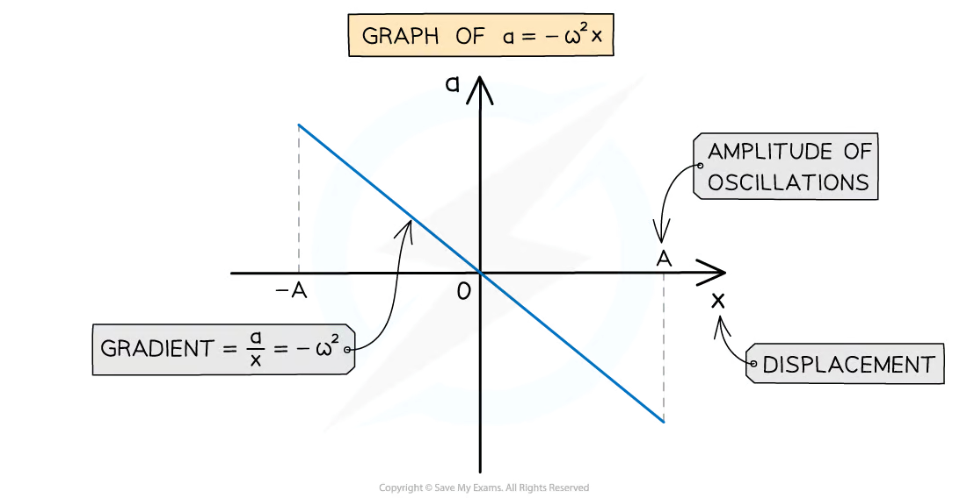
What are the equations for SHM for displacement, velocity and acceleration at a maximum value i.e a peak amplitude? | - x_{max} = A  - v_{max} = -A$ω$  - a_{max} = -$ω$²A

13.183 be able to use equations for a simple harmonic oscillator $T=2π\sqrt{\frac{m}{k}}$, and a simple pendulum $T=2π\sqrt{\frac{l}{g}}$
What are the equations for time period when dealing with mass based oscillators and pendulums | $T=2π\sqrt{\frac{m}{k}}$  - T² = 4$π$² x m/k  $T=2π\sqrt{\frac{l}{g}}$  - T² = 4$π$² x l/g

13.184 be able to draw and interpret a displacement–time graph for an object oscillating and know that the gradient at a point gives the velocity at that point
What do the displacement, velocity and acceleration graphs for SHM look like? | 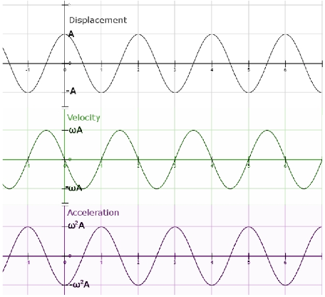  - x = Acos($ω$t)⍵  - v = -A$ω$sin($ω$t) the velocity is 90° out of phase with displacement  - a = -A$ω$²cos($ω$t) the acceleration is 90° out of phase with the velocity and 180° out of phase with the displacement

13.185 be able to draw and interpret a velocity–time graph for an oscillating object and know that the gradient at a point gives the acceleration at that point

13.186 understand what is meant by resonance
Define resonance? And what does it cause? | - When the frequency of a driving force is equal to the natural frequency which causes an increase in the amplitude of oscillations  - It occurs when there are no external forces or damping acting on it  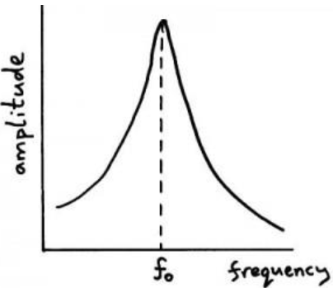  The driving frequency of the oscillator is plotted on the x-axis
What is natural frequency (f₀) and driving frequency (f_{d})? | - Natural frequency is the frequency at which the molecules of an object vibrate at naturally  - Driving frequency is the frequency provided by an external force to an oscilllator

13.187 CORE PRACTICAL 16: Determine the value of an unknown mass using the resonant frequencies of the oscillation of known masses.
What are modifications that you can do to improve the accuracy for an oscillation practical  (High chance to come up) | - Measure 10 oscillations (A longer time reduces %U in T)  - Use a fiducial marker at the reference position to reduce the effect of systematic error (Easier to determine when it passes a point)  - Use position of equilibrium as reference point  - Smaller angle of release where possible  - High-resolution of stopwatch (or of any equipment)  - Repeat measurements of time and calculate a mean time to reduce the effect of random error  - Time from the midpoint of the oscillation  - The students should let the pendulum swing back and to before starting the stopwatch (The 1st swing may be affected by students pushing the bob as they release it)  Measure at least 5 or more oscillations

13.188 understand how to apply conservation of energy to damped and undamped oscillating systems
Define damping? | The reduction in energy and amplitude of oscillations due to resistive forces on the oscillating system
What is important to remember for damped SHM oscillations? | - The frequency/time period of damped oscillations does not change
What is required of the damping force? | Its magnitude to be directly proportional to the frequency of the oscillator
What are the 3 types of damping with their associated graphs? | - Light damping:  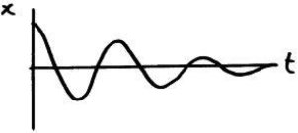  Reduces by the same fraction each cycle, more of less. Frequency stays the same for all 3  - Critical damping:  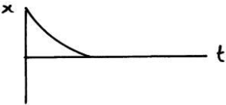  Used more often as it’s more comfortable (eg vehicle suspension systems and bikes breaks).  - Overdamping/Heavy damping:  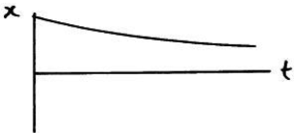  The damping force is so strong that the displaced object will return to equilibrium much more slowly (imagine it going in the opposite direction too.)
What is the equations for Total energy, KE energy, PE energy of an object under SHM | - TE = 1/2mA²$ω$²⍵  - KE = 1/2mA²$ω$²sin²$ω$t  - PE = 1/2mA²$ω$²cos²$ω$t  - KE_{max} = 1/2mA²$ω$²  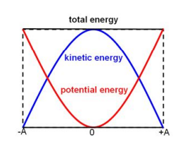

13.189 understand the distinction between free and forced oscillations
What is the definition of free and forced oscillations? | - Free - Oscillations where there are only internal forces (and no external forces) acting and there is no energy input  - Forced - Oscillations acted on by a periodic driving force (external force) where energy is given in order to sustain oscillations  Newton’s Cradle as a whole is a free oscillator but the bobs themselves are forced oscillators

13.190 understand how the amplitude of a forced oscillation changes at and around the natural frequency of a system and know, qualitatively, how damping affects resonance
What is the effect of damping on resonance? | 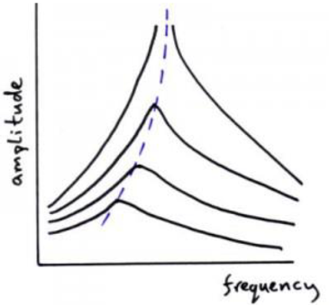  - The amplitude of resonance vibrations decrease meaning the peak of the curve lowers  - The resonance peak broadens  - The resonance peaks moves slightly to the left of the natural frequency when heavily damped  The lighter the damping, the closer to the resonant frequency is to the natural frequency of the object and the greater the amplitude  The natural frequency f₀ of the oscillator will remain the same

13.191 understand how damping and the plastic deformation of ductile materials reduce the amplitude of oscillation.
How does plastic deformation of a ductile material affect the amplitude of oscillations? | - It reduces it  - As energy from the oscillations is used to deform the material  - (The KE of the oscillator is reduced and transferred into the deformation of the material)  For example, a climbing rope is made to reduce the amplitude of oscillations if a climber falls as quickly as possible (this is critical damping), meaning that they can stay safe, while not having to bounce many times before stopping (as you would with a bungee cord). As the climbing rope suffers plastic deformation in order to reduce the amplitude of oscillations, it cannot be used a second time after a climber falls with it

